INDEX
LOCATION & ACCESSIBILITY
PROGRAM
FRIDAY APRIL 24TH 2026
SATURDAY APRIL 25TH 2026
SUNDAY APRIL 26TH 2026
FACILITY
PARTICIPATION
COMPETITION REGULATIONS
TANDING
COMPËTITION DURATION
EXEPTIONS
PROTECTION
PROTECTION - ALLOWED
PROTECTION - NOT ALLOWED
ARTISTIC
JUNIOR (14 TILL 16 YEAR)
SENIOR (17 AND OLDER) PROTEST
YELLOW AND RED CARD
SANCTION YELLOW CARD
SANCTION RED CARD
COMPETITION SCHEDULE
COMPETITION AREA
MATCH PREPARATION
VISITORS
CONTACT POINTS
RULES
ADDENDUM
NOT ALLOWED TECHNIC
ILEGAL STANDING TECHNICS
ILEGAL GROUND ATTACKS
ILEGAL TAKE DOWNS

Dear Coach / participant,

To lead the tournament in the right direction, to make it run smoothly and to give everyone a nice
experience.
We handover the Technical Handbook where you will find all information about the tournement,
accomodation and regulations.

In the interest of everyone, we ask that the mentioned rules and regulations are observed.

We wish all of you, participants and visitors a sportive and nice day.

Pieters L.
President of B.P.S.B

PROGRAM

FRIDAY APRIL 24TH 2026 |  |  | 10.00hrs – 12.00hrs:  Weight check hotel  14.00hrs – 18.00hrs:  Weight check Sporthall Vordenstein Schoten  20.00hrs- 22.00hrs  Opening – Demonstration - Artistic:
SATURDAY APRIL 25TH 2026 |  |  | 09.00hrs – 10.00 hrs
 |  |  | Weapon check Artistic
 |  |  | 09.30hrs – 10.00 hrs
 |  |  | Technical Meeting
 |  |  | 10.00hrs – 12.00 hrs
 |  |  | Competition
 |  |  | 12.00hrs – 13.00hrs: LUNCH
 |  |  | 13.00hrs – 18.00hrs:
 |  |  | Competition
 |  |  | 18.00hrs – 19.00hrs: DINNER
 |  |  | 19.00hrs – 22.00hrs:
 |  |  | Competition
SUNDAY APRIL 26TH 2026 |  |  | 09.00hrs – 12.00hrs:
 |  |  | Competition
 |  |  | 12.00hrs – 13.00hrs: | LUNCH
 |  |  | 13.00hrs- 18.00hrs:
 |  |  | Competition FINALS
 |  |  | 18.00hrs award ceremony
FACILITY AND PARTICIPATION

FACILITY

By arriving all participants and viewers can take place at the arena.

PARTCIPATION

Taking part on this event will be at your own risk.
By taking part every participant, minors or parents declare that the organisation is not responsible for any liability

Every participant or coaches must be aware of the regulations of the competitions which has been written in the International Pencak Silat Competition Rules and Regulations.

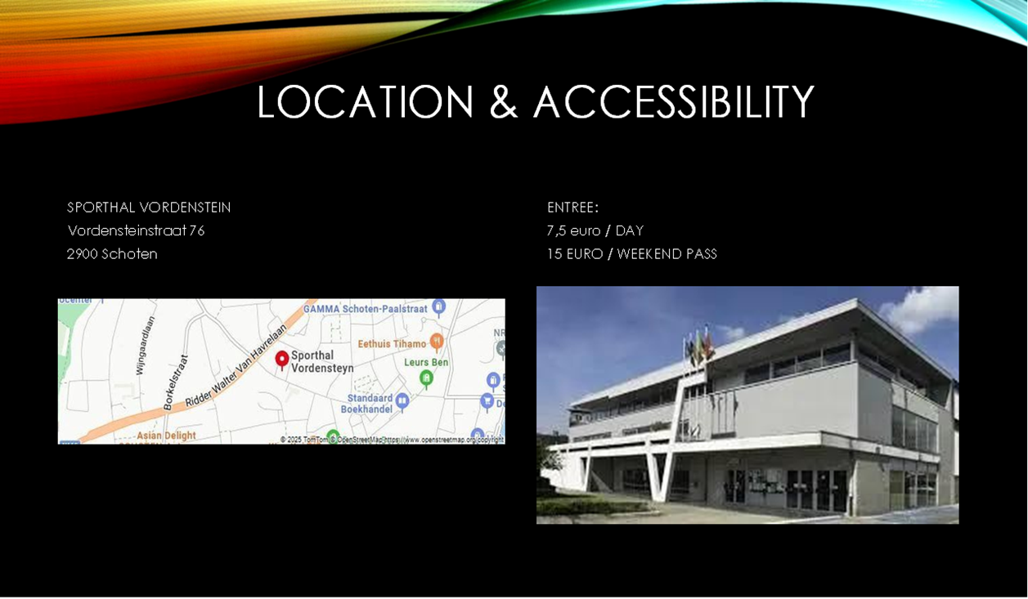

COMPETITION REGULATIONS

All competitions will be played concerning the recent International Pencak Silat Competition
Rules and Regulations

TANDING

Participants and Coaches will be wearing the Standard Model PENCAK SILAT UNIFORM (Black pains/black trouwsers) and an orange Sjerp for the coaches thru the competition. The bodyprotectors which are available at the arena can be used by the participants.

Protection Masters : Toque (mandatory), Shin protection is allowed (stocking model)
Protection Seniors : Toque (mandatory), Shin protection is allowed (stocking model)
Protection Juniors : Toque (mandatory), Shin protection is allowed (stocking model)

Match duration
The competitions will be played according the below mentioned times and rounds

Junior, Seniors and Masters
3 rounds of 2 minutes (depence of the number of participants)

Finals
3 rounds of 2 minustes (depence of the number of participants)

PROTECTION

During the matches, a number of protective equipment are allowed/mandatory or not allowed.

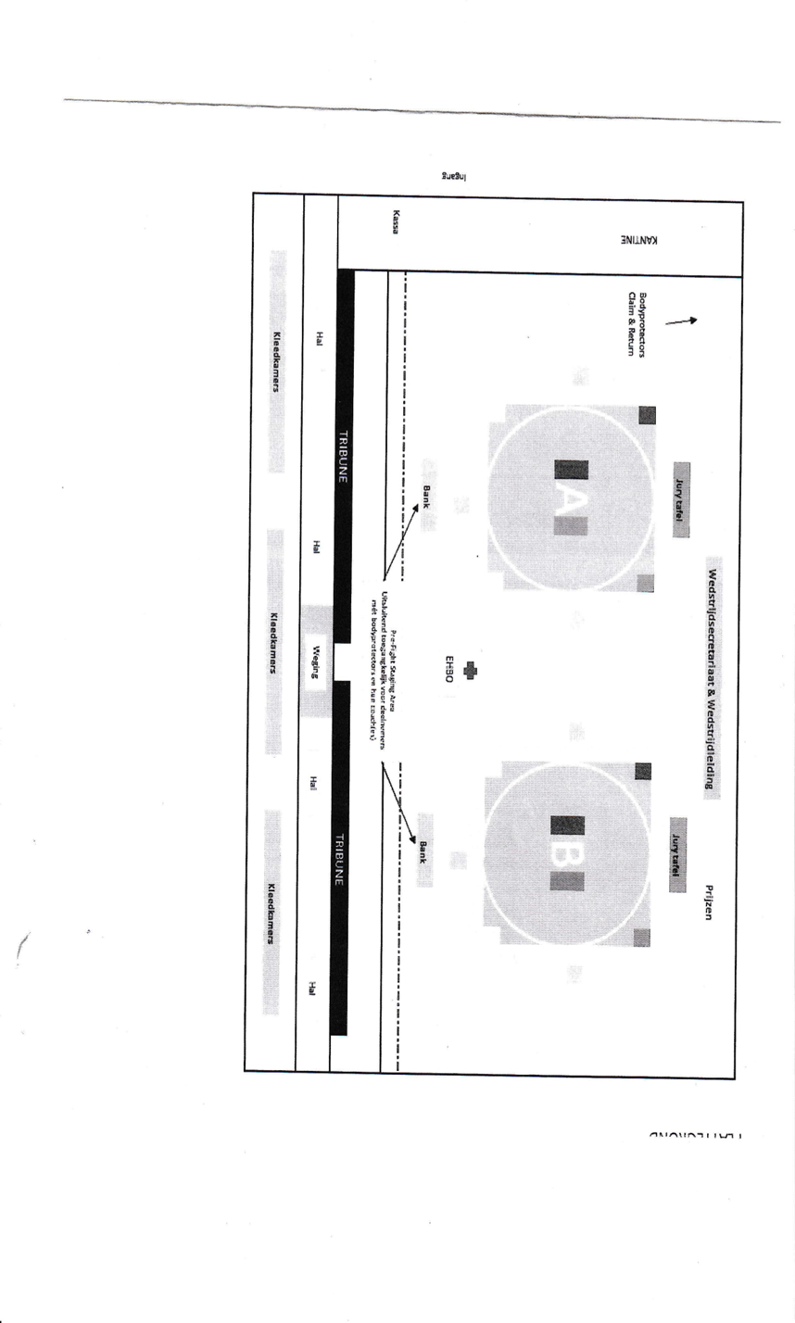

PROTEST
Protest Coach
During the competition, the coach is not allowed to communicate with the participant or referee.

The coach will receive 2 protest cards each match.
During the match, a protest can only be made against a decision of the referee.
The coach has to show the protest card. After the match the protest cards needs to be returned back.

Protest Teammanager
There is a possibility to submit at protest in writing. This protest must be submitted within 10 minutes after the announcement of the winner by the team manager/coach. The protest will be € 300,00 and will not be refunded. Regardless the protest will be assigned or not.

The judgment will be in the hands of the match president (KP) in agreement with the head of sports
matters.

PENALTY CARD
Every person present is required to adhere to the code of conduct. In order to ensure that the tournaments proceed in a sporting, friendly, and safe manner, we will therefore monitor the behavior of the players, coaches, and spectators more closely.

Yellow and red card
When there is a situation where the code of conduct is exceeded, the match will be put to rest. Depence of the seriousness of the situation, the yellow or red card will be shown.

Sanction of the yellow card
Frist an official warning. After the second yellow card, a red card will folow. There can not be protested against a yellow card.

Sanction red card
An unacceptable situation has arisen. As a result, there will be a direct removal of this person from the event. There can not be protested against an red card.

Artistic
The Artistic categories Tunggal, Ganda, Regu and Solo Creative will be conform with the rules of
PERSILAT

Junior (14 – 16 year)
Tungal/Ganda : complete equipment. Time limit 3 minutes
Regu : Can be executed as solo, duo or trio. Time limit 3 minutes
Solo creatief : armed or unarmed with a time limit of 1 – 3 minutes. Own music is allowed

Seniors 517 years and older)
Tungal/Ganda : complete equipment. Time limit 3 minutes
Regu : Can be executed as solo, duo or trio. Time limit 3 minutes
Solo creatief : complete equipment with a time limit of 1 – 3 minutes. Own music is allowed

Participants and coaches are allowed which clothing attire will be worn, as long as it meets the
requirements

PREPARATION OF THE MATCH

There will be information screens present with a schedule.;

Participants, coaches and supporters have the possibility to see when the next match will be played.

From the first call for his/her match or performance, the participant must proceed to the competition area and prepare for his/her match. Seats are ready for participants and coaches so that they are visible to the competition officials.

From the 2nd and 3rd calls onwards, they are made if the participant has not clearly appeared on the
field or has taken a seat. If the participant has not responded after the 3rd call, this may result in a
sanction, potentially disqualification. The sanction may also result in the awarding of a penalty point.

COMPETITION SCHEDULE

The matches are fairly and independently scheduled by means of a draw. This can mean that a team may have multiple members registered in the same class and have to compete against each other. This can be at the beginning of the tournament or at the end. The draw is decisive and there can be no deviation from it.

The arena
Body protectors of the organisation will be present and available for all participants.

Body protectors can be picked up before the match at the claim and return point and will be given with
a red or blue band.

After the match the body protector needs to be returned at the claim/return point.

Handle the materials carefully

Participants and their coaches from each class are all expected to take their designated place by the field where they will fight when it is their category's turn. For this, there are sports benches set up by the field.

The matches are played per class.

HOUSE RULES

- It is strictly prohibited to eat or drink at the arena
- The use of drugs and doping in and around the sport accomodation is prohibited
- Participants show respect towards eachother , even when the other party is not
- The wearing of rings, watches, earings, pearcings and other is not allowed for participants
- Discrimination, Cursing, coarse language, teasing, bullying, irritating, or harming anyone is not accepted and can lead to sanctions.
- It is strictly prohibited to smoke and consume alcohol in the building
- We have respect for material of other people, accomodation, gym and association
- you have good personal hygiene
- the use of poorly maintained and/or unsafe materials and tools is prohibited
- the gym is not to be entered with street shoes
- The participant is at all times required to report acute health problems.
- Any changes or additions will be discussed during the technical meeting.

VISITORS

Entree:
€7.50/ day
€15/ weekend pass

All visitors are required to take their seats in the designated stands, they are not allowed to go behind
the barrier in front of the playing field itself.

In relation to the visibility for the audience in the stands, all visitors are strongly urged not to stand along
the barrier of the stands.

Visitors to this event must fully adhere to the rules and regulations that apply in the venue and at all
times follow the instructions of the organization or staff of the sports facility.

There is supervision by a team of volunteers, these people follow instructions from the organization and
the sports facility to ensure your safety and the orderliness of the location.

Treat our volunteers with respect and always follow their instructions.

CONTACT POINTS

Pieters ludo
Ludo.pieters@telenet
+32 486.97.27.08

Pieters Kelly
kelly.pieters1983@gmail.com
+32 485.95.24.48

Pieters Wendy
Wendypieters_30@hotmail.com
+32 486.77.58.49

First aid personnel is always approachable and available for everyone.

